First name and last name ____________________________________________________

POL 138-003 Quantitative Reasoning in Political Science

Practice for Exam 2 [Page 2]

[Items 1 through 3] The table below indicates that, among a hypothetical set of workers at a company, 40% of women were promoted, but 60% of men were promoted.

Women |  |  |  | Men
Promoted | Sales | Client Rating | Experience | Promoted | Sales | Client Rating | Experience
No | $40 |  | 0 years | No | $40 |  | 0 years
No | $40 |  | 0 years | No | $40 |  | 10 years
No | $90 |  | 0 years | Yes | $40 |  | 10 years
Yes | $90 |  | 0 years | Yes | $90 |  | 10 years
Yes | $90 |  | 10 years | Yes | $90 |  | 10 years
- Controlling only for sales, the company's promotion practices seem ___.
- biased for women
- biased against women
- to not have a bias for or against women

- Controlling only for client rating, the company's promotion practices seem ___.
- biased for women
- biased against women
- to not have a bias for or against women

- Controlling only for experience, the company's promotion practices seem ___.
- biased for women
- biased against women
- to not have a bias for or against women

---

- The crime rate in Freedonia was rising 4 percent per year before 2022, but, at the start of 2022, Freedonia passed the Crime Reduction Act. The crime rate then rose by 1 percent per year after that. For estimating how the Crime Reduction Act affected crime rates in Freedonia, which of the following would provide the better comparison for a difference-in-differences design, based on only the crime rates indicated below?
- Oceania, in which the crime rate rose by 4 percent per year before 2022
- Pacifica, in which the crime rate rose by 1 percent per year after 2022
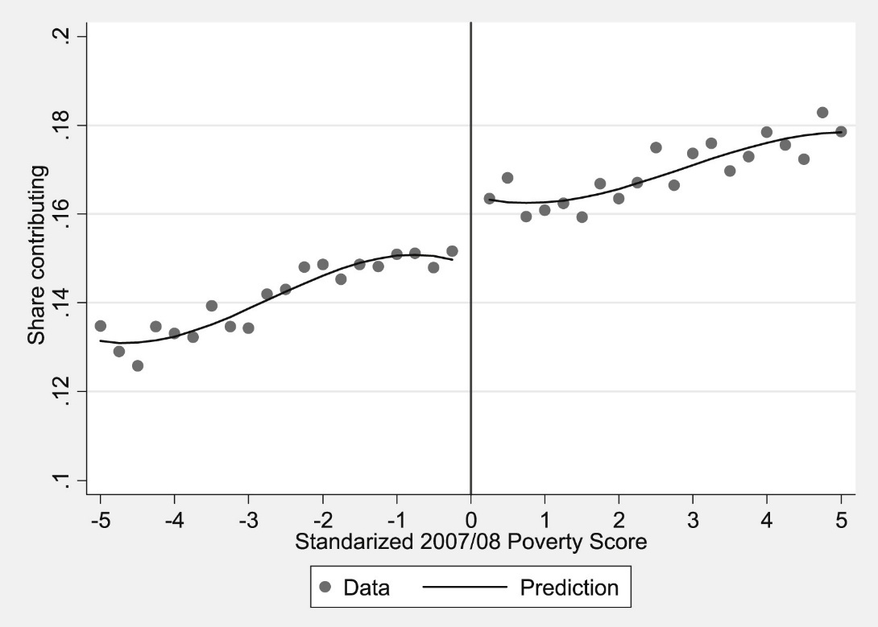

[Items 5 and 6] The plot above is from Bosch and Schady 2019, based on data from women in Ecuador. Zero on the horizontal x-axis indicates the poverty score cutoff for welfare: numbers above zero indicate that the woman had a high enough income so that she did not qualify for welfare, and numbers below zero indicate that the woman had a low enough income that she did qualify for welfare. The vertical y-axis indicates the share of women who contributed to Ecuador's social security program. We can estimate the effect of qualifying for welfare on the share of women who contribute to welfare, by comparing the predicted share of women who contribute to social security and barely qualified for welfare to the predicted share of women who contribute to social security and barely did not qualify for welfare, because these two groups of women should otherwise be relatively similar to each other.

- Which of the following indicates a benefit of this "barely" method, relative to comparing the share that contributed to social security among all women who qualified for welfare to the share that contributed to social security among all women who did not qualify for welfare?
- The "barely" method has a larger sample size.
- The "barely" method has a smaller sample size.
- The "barely" method better addresses alternate explanations.
- The "barely" method better meets the assumptions for a linear regression.

- Based on the lines of best fit, the best estimate is that qualifying for welfare caused ___ in the share of women who contributed to Ecuador's social security program.
- about a 0.050 decrease
- about a 0.030 decrease
- about a 0.013 decrease
- about a 0.013 increase
- about a 0.030 increase
- about a 0.050 increase

