POL 138-003 Quantitative Reasoning in Political Science

Practice for Exam 2 [Page 1]

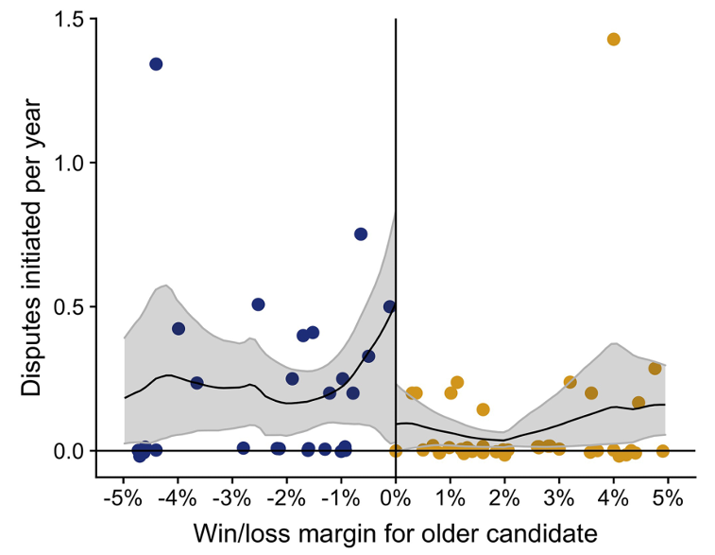

[Items 1 and 2] The plot above is from Bertoli et al. 2024 "Leader age and international conflict", which assessed whether the age of a country's leader affects the chance that the country initiates a military dispute with another country. The researchers used a regression discontinuity design (RDD) that compared, for elections involving a young candidate and an old candidate, the probability that a country in which the older candidate barely won election initiates a military dispute, to the probability that a country in which the older candidate barely lost election initiates a military dispute.

- Which of the following indicates a benefit of this RDD "barely" method, relative to comparing the probability that any country with an old leader initiates a military dispute, to the probability that any country with a young leader initiates a military dispute?
- The RDD method has a larger sample size.
- The RDD method has a smaller sample size.
- The RDD method better addresses alternate explanations.
- The RDD method better meets the assumptions for a linear regression.

- Based on the non-linear line of best fit in the plot, the best estimate is that, compared to younger leaders, older leaders ___.
- initiate about 0.4 fewer military disputes per year, on average
- initiate about 0.1 fewer military disputes per year, on average
- initiate about the same number of military disputes per year, on average
- initiate about 0.4 more military disputes per year, on average
- initiate about 0.5 more military disputes per year, on average

---
Ratings about police
 | White U.S. adults | Black U.S. adults | White/Black gap
Full population | 71 | 57 | 14
Democrats | 62 | 58 | 4
Independents | 68 | 55 | 13
Republicans | 82 | 71 | 11

- The table above reports how White U.S. adults and Black U.S. adults rated police on average, on a scale from 0 to 100, in the full population and disaggregated by political party (Democrat, Independent, and Republican). Compared to the White/Black gap in the full population, the White/Black gap in ratings about police is ___ when controlling for political party.
- smaller
- larger
- the same size
---

[Items 4 through 6] The table below indicates that, among a hypothetical set of workers at a company, 40% of women were promoted, but 60% of men were promoted.

Women |  |  |  | Men
Promoted | Sales | Client Rating | Experience | Promoted | Sales | Client Rating | Experience
No | $40 |  | 0 years | No | $40 |  | 0 years
No | $40 |  | 10 years | No | $40 |  | 0 years
No | $40 |  | 10 years | Yes | $90 |  | 0 years
Yes | $90 |  | 10 years | Yes | $90 |  | 0 years
Yes | $90 |  | 10 years | Yes | $90 |  | 10 years
- Controlling only for sales, the company's promotion practices seem ___.
- biased for women
- biased against women
- to not have a bias for or against women

- Controlling only for client rating, the company's promotion practices seem ___.
- biased for women
- biased against women
- to not have a bias for or against women

- Controlling only for experience, the company's promotion practices seem ___.
- biased for women
- biased against women
- to not have a bias for or against women

