POL 138-003 Quantitative Reasoning in Political Science

Final Exam MORE PRACTICE⋅ Fall 2025

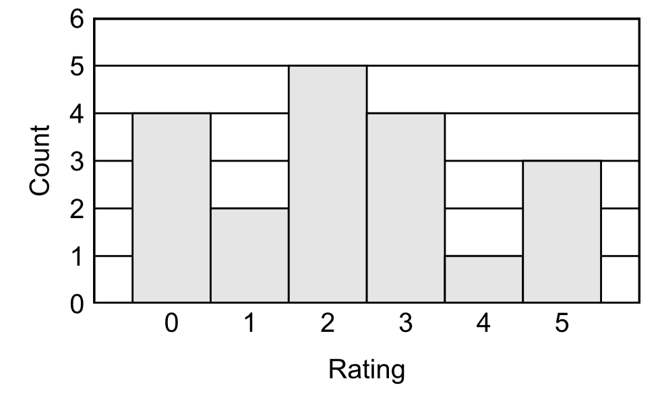
Based on the histogram above, which is true?
- There is 1 rating of 4.
- There are 4 ratings of 1.

Which score below indicates a higher degree of political knowledge for a political knowledge test?
- scoring at the 5th percentile on the test
- scoring at the 90th percentile on the test

Suppose that, in 2023, 40% of students at a college are women, but that, in 2024, 60% of students at the college are women. That change can be correctly expressed as an increase of ___.
- 50 percent
- 50 percentage points

Suppose that a course has two exams: Exam 1 is worth 30% of the overall grade for the course, and Exam 2 is worth 70% of the overall grade for the course. If a student scored 90% on Exam 1 and 40% on Exam 2, which of the following could be used to correctly calculate that student's overall percentage for the course?
- (0.30 × 90) + (0.70 × 40)
- (0.30 × 90) × (0.70 × 40)
- (0.30 × 90) ÷ (0.70 × 40)
- (0.30 × 70) − (0.90 × 40)

- Suppose that a test has a mean of 100 and a standard deviation of 15. Scores on the test follow a normal distribution. About 95% of scores should fall within which two scores?
- 0 and 100
- 60 and 140
- 70 and 130
- 80 and 120
- 90 and 110

Suppose that a researcher conducts a well-designed large-sample randomized experiment to test the null hypothesis that a treatment has no effect. In reality, the treatment has no effect. What is the expected probability that the p-value for the test of the null hypothesis is p=0.05 or less?
- 0%
- above 0% but less than 5%
- 5%
- above 5%
- Cannot be determined without more information

[Items 7 and 8] A researcher randomly selects 2,000 people from the population of U.S. residents and then randomly assigns 1,000 of these people to a group that receives Treatment A and randomly assigns the other 1,000 people to a group that receives Treatment B.

The random selection from the population ___.
- better permits the researcher to make an inference about U.S. residents
- better permits the researcher to make an inference about whether Treatment A has a different effect than Treatment B has among participants in the sample
The random assignment to groups ___.
- better permits the researcher to make an inference about U.S. residents
- better permits the researcher to make an inference about whether Treatment A has a different effect than Treatment B has among participants in the sample

Below is adapted from the abstract for Poulson 1990:

This randomized experiment systematically varied the race of a defendant to be black or white. The mock trial was presented to 197 college students by means of an audiotape and slide show. Following the re-enacted trial, subjects answered a series of questions regarding the case. Analyses revealed a significant relationship such that the defendant, when presented as black, was acquitted as not guilty by reason of insanity significantly more often than when the defendant was presented as white.

Which of the following best indicates the validities of this study, for understanding how the race of a defendant affects how jurors in the criminal justice system evaluate the defendant's suitability to be found not guilty by reason of insanity?
- low internal validity and low external validity
- low internal validity and high external validity
- high internal validity and low external validity
- high internal validity and high external validity

In November 2025, Illinois State University Emerita Associate Professor of Sociology Dr. Maria Schmeeckle planned to offer a talk entitled "Rebels With a Cause: The Lifelong Impact of Children's Rebellion against Parents". The description of her research indicated that "This talk presents findings from my qualitative sociological study of adults who rebelled in childhood against their parents or ___". Of the following, which is the best way to finish that sentence, to reflect the best research design of the options below?
- adults who did not rebel in childhood against their parents
- adults who wanted to rebel in childhood against their parents but did not
- adults who rebelled in adulthood against their parents

Suppose that the President of Freedonia forgave $1,000 in student loan debt for any person who had at least $10,000 in student loan debt. Which of the following would be a better research design for assessing whether this debt forgiveness increased approval of the President of Freedonia among persons who received this debt forgiveness?
  - Compare the mean approval of the President of Freedonia among persons who received this debt forgiveness, to the mean approval of the President of Freedonia among persons who did not receive this debt forgiveness
  - Compare the mean approval of the President of Freedonia among persons who, before the debt forgiveness, had between $10,000 and $10,500 in student loan debt, to the mean approval of the President of Freedonia among persons who, before the debt forgiveness, had between $9,500 and $9,999 in student loan debt

Suppose that scores on a national test follow a normal distribution and have a mean of 100 and a standard deviation of 10. If Student A raises her score from 95 to 105, and Student B raises her score from 120 to 130, which of the following statements is true?
- Student A had the higher percentile increase on the test.
- Student B had the higher percentile increase on the test.
- Student A had the same percentile increase on the test as Student B had.

Each table below has data for two men in three years, indicating each man's marital status on January 1 of that year and that man's rating about women later that year. In both tables, there is a positive association between a man being married and a man's rating about women.

Table A |  |  |  |  | Table B
Man | Year | Marital  status | Rating  about  women |  | Man | Month | Marital  status | Rating  about  women
1 | 1 | Unmarried | 20 |  | 1 | 1 | Unmarried | 10
1 | 2 | Unmarried | 20 |  | 1 | 2 | Unmarried | 10
1 | 3 | Married | 30 |  | 1 | 3 | Married | 10
2 | 1 | Unmarried | 40 |  | 2 | 1 | Unmarried | 60
2 | 2 | Married | 60 |  | 2 | 2 | Married | 60
2 | 3 | Married | 60 |  | 2 | 3 | Married | 60

For which table do the data more strongly suggest that the positive association between being married and higher ratings about women is because getting married causes a man to have higher ratings about women?
- Table A
- Table B

Suppose that, for a randomized experiment, the estimated effect size of the treatment is 6, with a p-value of p<0.05 for a test of the null hypothesis that the treatment effect is zero. But the research design is biased in a way that causes the estimated effect size to be lower than the true effect size. Which, if any, of the following can we therefore conclude at the conventional level in political science, about the true treatment effect for this experiment?
- The treatment effect truly exists.
- The treatment effect truly does not exist.
- Neither of the above

- If we flipped a coin 40 times and got 20 heads and 20 tails, what would be the p-value for a test of the null hypothesis that the coin is fair?
- 0
- 1
- something between 0 and 1

- If we flipped a coin 40 times and got 30 heads and 10 tails, what would be the p-value for a test of the null hypothesis that the coin is fair?
- 0
- 1
- something between 0 and 1

- If we flipped a coin 40 times and got 40 heads and 0 tails, what would be the p-value for a test of the null hypothesis that the coin is fair?
- 0
- 1
- something between 0 and 1

- If the p-value for a test of a null hypothesis is p=0.03, then we should do which of the following?
- accept the null hypothesis and accept the alternative hypothesis
- reject the null hypothesis and reject the alternative hypothesis
- accept the null hypothesis and reject the alternative hypothesis
- reject the null hypothesis and accept the alternative hypothesis
- none of the above

- If the p-value for a test of a null hypothesis is p=0.60, then we should do which of the following?
- accept the null hypothesis and accept the alternative hypothesis
- reject the null hypothesis and reject the alternative hypothesis
- accept the null hypothesis and reject the alternative hypothesis
- reject the null hypothesis and accept the alternative hypothesis
- none of the above

- A researcher tested the null hypothesis that an association is zero. The p-value for this test is p=0.03. Based on this p-value, which of the following should the researcher do, using the conventional level in political science?
- conclude that the association is zero
- conclude that the association is not zero
- neither of the above

- A researcher tested the null hypothesis that an association is zero. The p-value for this test is p=0.60. Based on this p-value, which of the following should the researcher do, using the conventional level in political science?
- conclude that the association is zero
- conclude that the association is not zero
- neither of the above

- Suppose that a researcher has the data below, from two participants (ID #1 and ID #2) from a survey in April and a survey in June of the same year. For each participant and for both months, the dataset has an indication of the participant's political party (D or R) and an indication of whether the participant supports or opposes affirmative action:

ID | April | June
1 | D + Oppose | R + Oppose
2 | R + Support | D + Support

Based on these data only, which of the following is more supported?
- political party influences attitudes about affirmative action
- attitudes about affirmative action influences political party

GDP per capita rose in Fredonia 3 percent per year from 2020 to 2023. At the start of 2024, Freedonia implemented the GDP Growth Act, and, in 2024, GDP per capita rose 5 percent. For estimating how the GDP Growth Act affected GDP per capita growth in Freedonia, which of the following would provide the better comparison for a difference-in-differences design, based on only the information indicated below?
- Atlantica, in which GDP per capita rose by 5 percent per year from 2020 to 2023
- Oceania, in which GDP per capita rose by 3 percent per year from 2020 to 2023
- Pacifica, in which GDP per capita rose by 5 percent per year in 2024
- Arctica, in which GDP per capita rose by 3 percent per year in 2024

